 

**COLLEGE CODE**: 9623

**COLLEGE NAME**: AMRITA COLLEGE OF

ENGINEERING AND TECHNOLOGY

**DEPARTMENT**: COMPUTER SCIENCE AND

ENGINEERING

**STUDENT NM-ID**:

F9F820B4B8EFF12A955428C2077D5ACA

**ROLL NO**: 962323104059

**DATE**: 07-10-2025

COMPLETED THE PROJECT NAMED AS PHASE 5

TECHNOLOGY PROJECT NAME: PORTFOLIO WEBSITE

**SUBMITTED BY,**

**NAME**: S.MITHUN KRSHNA

**MOBILE.NO**:6379567322

**Project Overview**

The **Portfolio Website** is a fully responsive and animated web application designed to showcase personal skills, projects, achievements, and contact information of a developer.  
It acts as a **digital resume and personal brand identity** for professionals, especially web developers and designers.

The website includes:

* A visually appealing homepage introducing the developer.
* An about section displaying skills, education, and experience.
* A projects section showcasing major works with live links and GitHub repositories.
* A contact form integrated with email functionality.
* Modern animations, transitions, and responsiveness across all devices.

The main objective is to create a **professional online presence** and demonstrate **frontend & backend integration** using modern web technologies.

**Project Report**

The **Portfolio Website** project was developed using **HTML5, CSS3, JavaScript, and React.js**, with backend support through **Node.js and Express.js** for contact form handling.  
The design was implemented with **Tailwind CSS** for a sleek, modern interface and **Framer Motion** for animations.

**Key Features**

1. **Responsive Design:** Works seamlessly on desktop, tablet, and mobile.
2. **Animated UI:** Smooth scrolling and motion effects for user engagement.
3. **Dynamic Project Section:** Fetches project data from a JSON or database.
4. **Interactive Contact Form:** Sends messages directly to email using Node.js backend.
5. **Dark/Light Mode Toggle:** Enhances usability and user experience.

**Technology Stack**

* **Frontend:** HTML, CSS, JavaScript, React.js, Tailwind CSS, Framer Motion
* **Backend:** Node.js, Express.js
* **Version Control:** Git & GitHub
* **Deployment:** GitHub Pages / Vercel

**Structure**

* Home Page: Introduction with hero animation and navigation links.
* About Page: Bio, education, and skills with progress bars.
* Projects Page: Grid cards showcasing projects with hover animations.
* Contact Page: Contact form with live message submission.
* Enhancements & Deployment Page: Details of hosting, improvements, and updates.

**Screenshots:**

**GITHUB REPOSITORY IMAGE:**

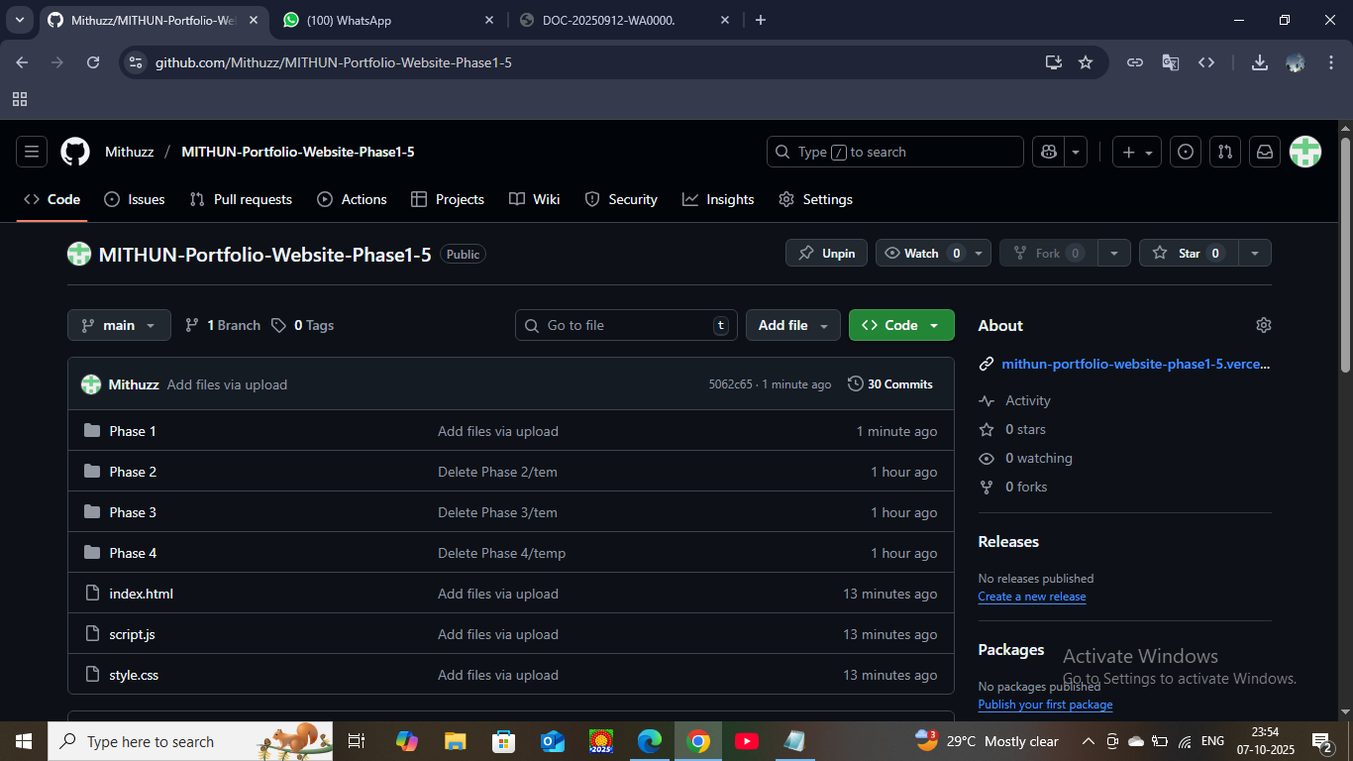

**WEBSITE IMAGE:**

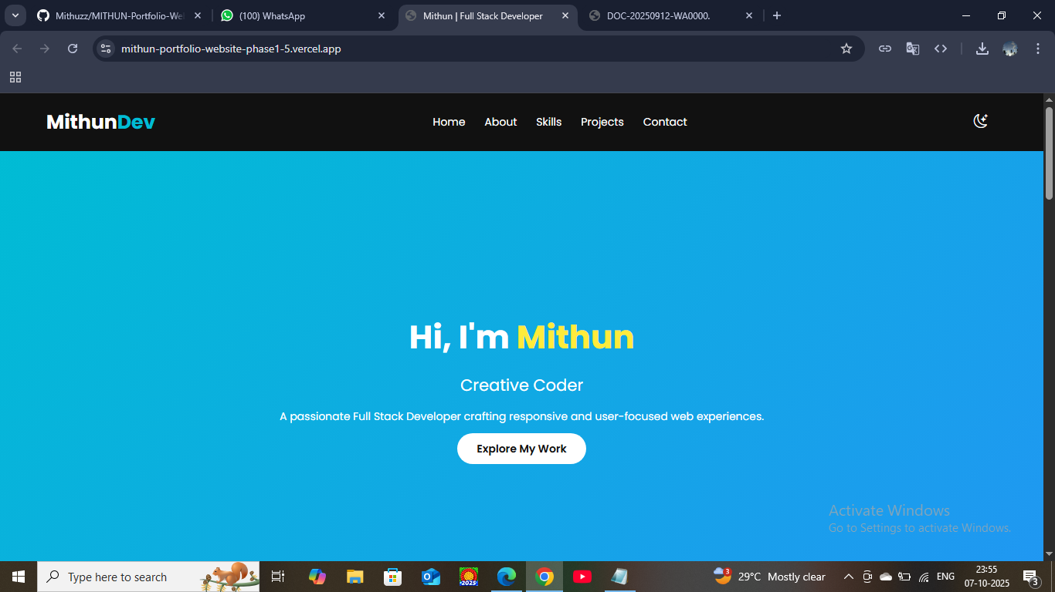

**Challenges & Solutions**

| **Challenge** | **Description** | **Solution Implemented** |
| --- | --- | --- |
| Responsive Layout | Difficulty maintaining layout consistency on smaller screens | Used Tailwind CSS grid and flex utilities for better control |
| Animation Lag | Animations caused delay in rendering | Optimized motion using Framer Motion's useReducedMotion hook |
| Contact Form Validation | Errors in backend email response | Added Express middleware for error handling |
| GitHub Deployment | Issues with routing on refresh | Used HashRouter in React for static page hosting |

**GitHub Link**

**GitHub Repository:** [**https://github.com/Mithuzz/MITHUN-Portfolio-Website-Phase1-5**](https://github.com/Mithuzz/MITHUN-Portfolio-Website-Phase1-5)

**DEPLOYED WEBSITE LINK: USING VERCEL:**

[**https://mithun-portfolio-website-phase1-5.vercel.app/**](https://mithun-portfolio-website-phase1-5.vercel.app/)

**Conclusion**

The **Portfolio Website** successfully demonstrates personal branding, responsive design, and real-time interaction features.  
It highlights the developer’s technical expertise and creativity while serving as a live resume accessible globally.